KJSCE/IT/SYBTech/SEM IV/AA/2020-21


Experiment No. : 8

Title: 15 puzzle problem using Branch and bound

(Autonomous College Affiliated to University of Mumbai)
KJSCE/IT/SYBTech/SEM IV/AA/2020-21

Batch:B2

Roll No.:1914078

Experiment No.:8

Aim: Implement 8/15 puzzle problem using Branch and bound.

Algorithm:

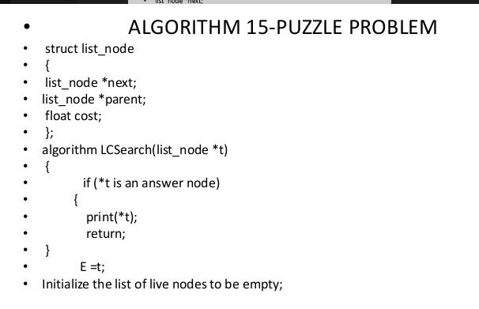
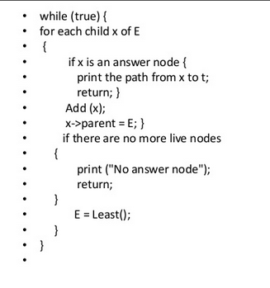
Example of 8/15 puzzle problem using Branch and bound Step by Step Execution

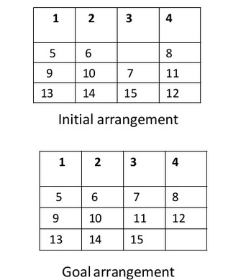
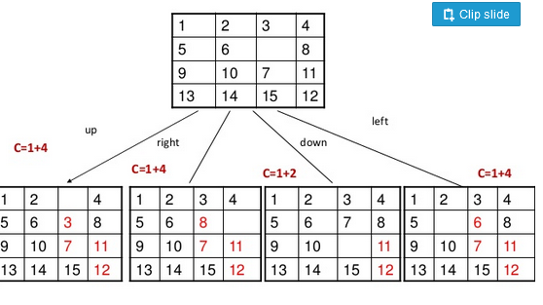
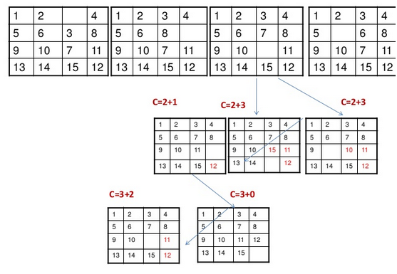

(Autonomous College Affiliated to University of Mumbai)

KJSCE/IT/SYBTech/SEM IV/AA/2020-21

Derivation of Analysis:

Time complexity.

2^^{n}

Program(s):
import java.util.Scanner;

public class AAPuzzle {
public static void main(String args[]) {
Scanner src = new Scanner(System.in);
System.out.println("Enter the initial values (enter -1 for blank space): ");
int [][] mat = new int[4][4];
int [][] goal = new int[4][4];
int i_blank=0,j_blank=0;
for(int i=0;i<4;i++) {
for (int j = 0; j < 4; j++) {
mat[i][j] = src.nextInt();
goal[i][j] = (i*4)+j+1;
if(mat[i][j]==-1) {
i_blank = i;
j_blank = j;
}
}
}
System.out.println("The problem : ");
printStage(mat);
branch(mat,i_blank,j_blank,0,-2,goal);
}
public static void branch(int[][] a,int x,int y,int inc,int moved_to,int[][] goal){
if( computeDifferences(a,goal)==0){
return;
}
int final_i = 0;
int opt_sol = 20;
int temp[][];
int temp_i,temp_j;
for(int i=0;i<4;i++){
temp = copy_array(a);
if(Math.abs(i-2)!=moved_to){
temp_i = x+((i-1)%2);
temp_j = y+((2-i)%2);
if(temp_i>=0 && temp_i<4 && temp_j>=0 && temp_j<4) {
temp[x][y] = temp[temp_i][temp_j];
temp[temp_i][temp_j] = -1;
int cost = computeDifferences(temp,goal);
if(cost == 0){
final_i=i;
break;
}
if(cost<opt_sol){
opt_sol = cost;
final_i=i;
}

}
}
}
temp_i = x+((final_i-1)%2);
temp_j = y+((2-final_i)%2);
a[x][y] = a[temp_i][temp_j];
a[temp_i][temp_j] = -1;
inc++;
System.out.println();
System.out.println("After stage "+(inc)+": ");
printStage(a);
branch(a,temp_i,temp_j,inc,final_i,goal);

}
public static int computeDifferences(int[][] a,int [][]b) {
int count = 0;
for (int i = 0; i < 4; i++) {
for (int j = 0; j < 4; j++) {
if (a[i][j] != b[i][j] && a[i][j] != -1)
count++;
}
}
return count;
}
public static void printStage(int [][]a){
for (int i = 0; i < 4; i++) {
for (int j = 0; j < 4; j++) {
System.out.print(String.format("%2d ",a[i][j]));
}
System.out.println();
}
}
public static int[][] copy_array(int[][]a){
int [][]x = new int[4][4];
for (int i = 0; i < 4; i++) {
for (int j = 0; j < 4; j++) {
x[i][j] = a[i][j];
}
}
return x;
}
}

Output(o):

Input:

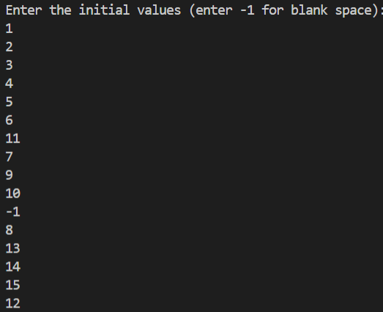

Output

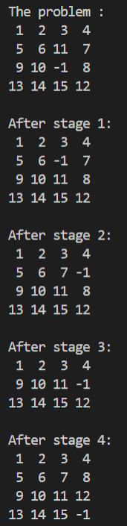 (Autonomous College Affiliated to University of Mumbai)
KJSCE/IT/SYBTech/SEM IV/AA/2020-21

Questions:- Explain how to solve the Knapsack problem using branch and bound.
Ans)
- Draw a table say ‘T’ with (n+1) number of rows and (w+1) number of columns.
- Fill all the boxes of 0th row and 0th column with zeroes as shown-

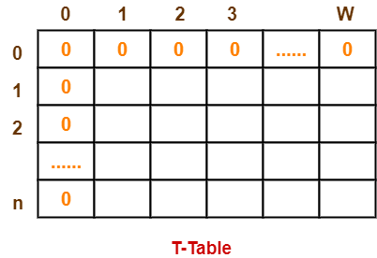

Step-02:

Start filling the table row wise top to bottom from left to right.
Use the following formula-
T (i , j) = max { T ( i-1 , j ) , value_{i} + T( i-1 , j – weight_{i} ) }

Here, T(i , j) = maximum value of the selected items if we can take items 1 to i and have weight restrictions of j.

- This step leads to completely filling the table.
- Then, value of the last box represents the maximum possible value that can be put into the knapsack.

Step-03:

To identify the items that must be put into the knapsack to obtain that maximum profit,
- Consider the last column of the table.
- Start scanning the entries from bottom to top.
- On encountering an entry whose value is not same as the value stored in the entry immediately above it, mark the row label of that entry.
- After all the entries are scanned, the marked labels represent the items that must be put into the knapsack.

Outcome:

Understand Backtracking and Branch-and-bound algorithms

Conclusion: (Based on the observations):
Learned about 15 puzzle problem and solved it using branch and bound approach

References:

- Richard E. Neapolitan, " Foundation of Algorithms ", 5th Edition 2016, Jones & Bartlett Students Edition

- Harsh Bhasin , " Algorithms : Design & Analysis", 1st Edition 2013, Oxford Higher education, India

- T.H. Coreman ,C.E. Leiserson,R.L. Rivest, and C. Stein, " Introduction to algorithms", 3rd Edition 2009, Prentice Hall India Publication

(Autonomous College Affiliated to University of Mumbai)

